
Amity University Online
III-Semester MCA Project Report On

Title of the Project
“Space Industry Reliability Study and Success Prediction using Comparative ML Models”

Submitted by
Name: A NAGASHESHU
Enrolment no: A9929724001270(el)

……..............................

CERTIFICATE OF COMPLETION
This is to certify that
A NAGASHESHU
has successfully completed the project entitled
“Space Industry Reliability Study and Success Prediction using Comparative ML Models”
as part of their academic requirements in the field of MCA.
This project has been carried out with dedication, adhering to research methodologies, and demonstrates an in-depth understanding of the topic.

Submission Date:23/11/2025

DECLARATION

I, A Nagasheshu a student of Amity University Online, hereby declare that the project entitled “Space Industry Reliability Study and Success Prediction using Comparative ML Models” is my original work and no part of it has been submitted for any other degree purpose or published in any other from till date
..............................

ABSTRACT

The reliability of space launch companies plays a crucial role in determining performance consistency, technological dependability, and operational success within the global space sector. In recent years, the growing competition among global space organizations has made reliability a key determinant of mission success, client trust, and industry reputation. This project aims to evaluate the reliability of various space companies using historical launch data while leveraging machine learning models to predict future mission outcomes. The analysis focuses on understanding launch trends, calculating success ratios for different providers, and identifying the key parameters that influence the probability of mission success. Using real world data encompassing multiple decades of space launches, the study systematically evaluates the success and failure trends of different space agencies and private companies to establish a data driven reliability index. Several machine learning algorithms are trained and compared to assess their predictive accuracy, robustness, and interpretability.
The results of this study highlight not only the most consistent and dependable launch providers but also the most effective machine learning model for forecasting launch success. By combining data analytics with predictive modelling, this project contributes valuable insights toward performance benchmarking and decision support in the space industry. Moreover, the findings derived from this study hold practical significance for various stakeholders within and beyond the space sector. Businesses seeking to deploy commercial satellites can utilize the reliability insights to identify launch service providers with proven performance consistency, minimizing the risks associated with mission failures and financial losses.

TABLE OF CONTENTS

Sl no | Contents | Page no
1 | Certificate | 2
2 | Declaration | 3
3 | Abstract | 4
4 | Introduction to the study | 6
5 | Objectives of the study | 7
6 | Literature review | 8
7 | Research methodology | 10
8 | Data interpretation | 13
9 | Results and Insights from Data Analysis | 15
10 | Recommendations and Conclusions | 32
11 | Bibliography & references: | 33
12 | Appendix | 34

INTRODUCTION TO THE STUDY
The rapid growth of the global space industry has led to increased competition among commercial and government launch providers. As the demand for satellite-based communication, navigation, and research continues to rise, the need for dependable and consistent launch performance has become more critical than ever. Evaluating the reliability of space launch companies is essential to ensure mission success, minimize financial risk, and enhance trust among clients and investors. “The first step to ensure the reliability of new launch vehicles is to analyse previous launch failures, learning from past mistakes.” (Fernandez et al., 2022)."
Historical launch records provide valuable insights into patterns of success and failure that can be used to understand a company’s technological maturity and operational consistency. However, determining the likelihood of success for future missions requires more than descriptive statistics; it demands predictive analytics capable of identifying hidden trends and performance indicators. Modern reliability research emphasizes that advanced analytical tools and probabilistic methods are essential for meaningful risk evaluation (Guarro, 2018).
Through this project, reliability assessment becomes more systematic and data driven, helping stakeholders such as satellite operators, investors, and research organizations make informed decisions when selecting launch partners. By integrating reliability analysis with predictive modeling, this study contributes a comprehensive framework for understanding organizational performance within the space industry. The insights derived from this analysis can support decisionmakers, researchers, and commercial stakeholders in selecting dependable launch providers and enhancing mission planning strategies.

OBJECTIVES OF THE STUDY
Ensuring the reliability of the space industry begins with a systematic evaluation of historical mission data, particularly focusing on understanding the factors behind both successful and failed launches, allowing engineers to learn from prior mistakes and improve future designs. By learning from past launch data, this study aims to establish a foundation for data driven reliability assessment and prediction.
The main objectives of the project are as follows:
- To ensure the reliability assessment of each space launch company through the calculation of success ratios and the examination of historical launch records, thereby identifying patterns of consistency or dependability in mission performance.
- To develop and compare multiple machine learning models such as Logistic Regression, Random Forest, and Neural Network classifiers to predict the likelihood of success in future launches.
- To determine the most effective and interpretable model for forecasting launch outcomes, providing an analytical basis for understanding company reliability and mission predictability.
Through these objectives, the study seeks to combine reliability analysis with predictive modeling to contribute toward more informed and systematic decision making in the assessment of space launch performance. By achieving these objectives, the study aims to bridge the gap between historical reliability assessment and modern predictive analytics. The findings are expected to assist research institutions, commercial satellite operators, and governmental agencies in selecting the most dependable launch providers, thereby enhancing mission assurance, operational efficiency, and confidence in space-based ventures.
LITERATURE REVIEW

Theoretical Background

The space industry’s reliability has long been a key indicator of technological progress and mission assurance. Reliability engineering forms the foundation for assessing the performance of launch systems through statistical measures such as success ratios and failure rates. With the rise of large historical datasets, machine learning (ML) techniques such as Logistic Regression, CatBoost, Random Forest, and Neural Networks have emerged as effective tools for predictive reliability analysis. These models help identify hidden patterns in launch data and improve success prediction accuracy (Goodfellow et al., 2016). By integrating reliability engineering with ML, this study aims to determine the most dependable space launch company and forecast mission outcomes with greater precision.

Methodological Background

Previous research in the field of space launch analysis has primarily focused on using historical launch data to visualize patterns and examine the distribution of successful and failed missions across various providers, rockets, and launch sites in contrast, the present study extends this approach by integrating additional parameters such as weather data including temperature, humidity, pressure, and wind speed which play a significant role in determining mission outcomes. By considering these environmental factors, the study aims to uncover deeper correlations between launch conditions and success rates, thereby adding value to the overall reliability analysis.

Key Findings from Prior Research
While earlier studies emphasized trend visualization and comparative performance across companies, the current research introduces a more data driven approach by employing multiple machine learning models including Logistic Regression, Random Forest, and Neural Networks to evaluate model performance and predictive accuracy. The main objective is to derive reliability metrics that quantify the dependability of each space launch company. This methodological advancement provides a foundation for identifying the most reliable providers for future satellite launches and contributes to better decision making in commercial and scientific mission planning.

RESEARCH METHODOLOGY

METHODOLOGY ADOPTED:
The methodology adopted for this study combines descriptive and exploratory approaches. The descriptive aspect focuses on summarizing and analysing historical launch data to measure the reliability of space launch providers, while the exploratory part involves developing predictive models to identify patterns and relationships that influence mission success.

RESEARCH DESIGN:
The research design adopted in this study is both Descriptive and Exploratory.
- The descriptive design helps in summarizing past space launch records, computing success ratios, and comparing the performance of different companies.
- The exploratory design focuses on identifying significant predictors of mission success, such as weather parameters (temperature, humidity, wind speed, and pressure), and applying machine learning algorithms to predict the likelihood of future launch outcomes.

DATA COLLECTION METHODS:

Primary Data:

No primary data collection was conducted, as the study is based entirely on secondary data sources. However, the data was cleaned, processed, and analysed to ensure reliability and consistency.

Secondary Data:
The secondary data for this study was obtained from publicly available space launch databases and open-source repositories such as Kaggle. Additionally, Open-Meteo API were utilized to gather historical weather information corresponding to each launch event. The geographical coordinates of launch sites were retrieved using the Geopy library to accurately map the weather conditions at the time and location of each mission. The compiled dataset includes key parameters such as company name, rocket type, launch site, launch date, mission status (success/failure), and atmospheric variables like temperature, pressure, humidity, and wind speed during launch. This comprehensive dataset enables both reliability assessment and predictive modeling of space mission outcomes.

SAMPLE SIZE:
A total of 6,743 launch records, spanning from 1957 to the present, were collected for analysis. The dataset encompasses missions conducted by multiple space agencies and private companies, capturing both successful and failed launches to provide a comprehensive overview of global launch activity over time.

STATISTICAL TOOLS:
The statistical and analytical tool used in this study is Python, which was employed for data preprocessing, exploratory analysis, model training, and evaluation of machine learning algorithms.

METHOD USED TO PRESENT DATA
The data analysis and interpretation process involved the classification and tabulation of raw data into meaningful categories. The key steps included:
- Performing simple tabulation to summarize company-wise performance.
- Calculating success ratios to measure the reliability of each company based on historical data.
- Visualizing patterns and relationships through pie charts, line graphs, and comparative plots of model accuracy.
The Reliability (Success Ratio) was computed using a standard formula, which is detailed in the Data Analysis & Interpretation section. This approach allowed for systematic assessment of launch performance and a clearer comparison of reliability across different space companies.

Data interpretation

Dataset Description
The dataset used for this study consists of 6,743 space launch records collected from publicly available databases (Kaggle and open APIs). It covers launches from 1957 to the present, including missions conducted by both government and private space organizations.
Key Attributes (Before Feature Engineering):
- Provider - Name of the space organization or company.
- Rocket -The launch vehicle name or family.
- Mission – Name of the mission.
- Launch Pad - Specific launch site used for the mission.
- Date and Time - Year, hour, and minute of launch.
- Mission Status - Outcome of the mission (Success/Failure).
Feature Engineering:
To enhance the dataset for predictive modeling, additional derived features were created:
Feature | Extracted Feature | Description / Purpose
Date Time | Date, Time, Hour, Month, Year, Decade, Season, AmPm | Extracted individual temporal components to analyse launch trends over time, across seasons, and by time of day.
Provider Name | Provider Type | Grouped providers into categories such as Military, Scientific, Commercial, and Government to simplify analysis.
Launch Pad | Coordinates | Extracted Coordinates of that launchpad using Geopy library
Coordinates, Date, Time | Wind speed, temperature, pressure, humidity | Extracted Weather data from coordinates, date and time using Open-Metro Api
The feature engineering and preprocessing steps were implemented using Python. For detailed code snippets and implementation references, please refer to Appendix A1.

Results and Insights from Data Analysis

Q1. Number of Launches per Provider
This chart illustrates the total number of launches conducted by each provider since 1957, highlighting the scale of operations across different organizations.

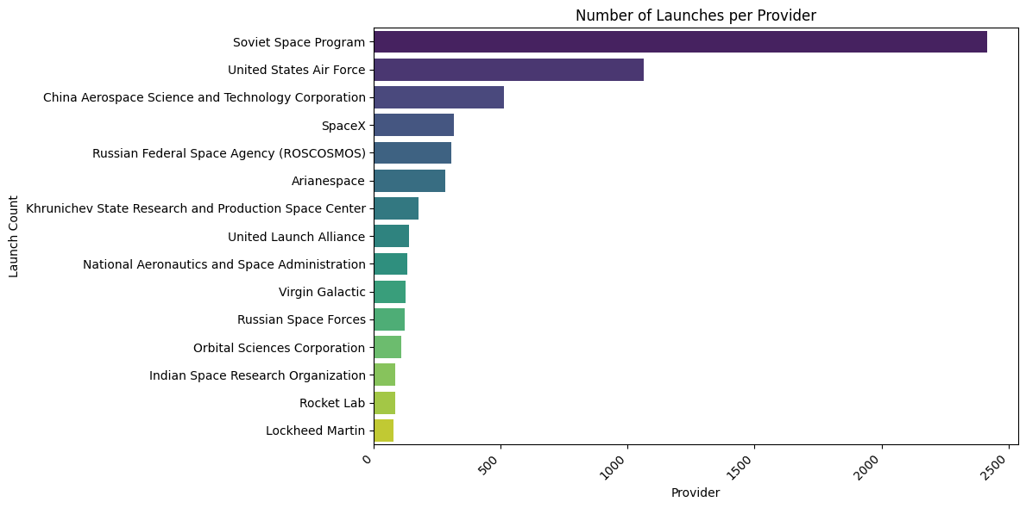
Figure 1.1
Interpretation: Providers like Soviet Space program, United States air force, SpaceX, Roscosmos, and NASA dominate the launch frequency, indicating their long-standing presence and operational capacity in the global launch market.

Q2. Launch Success vs Failure Rate by Provider
This analysis compares the number of successful and failed launches for each provider, offering insights into reliability differences.
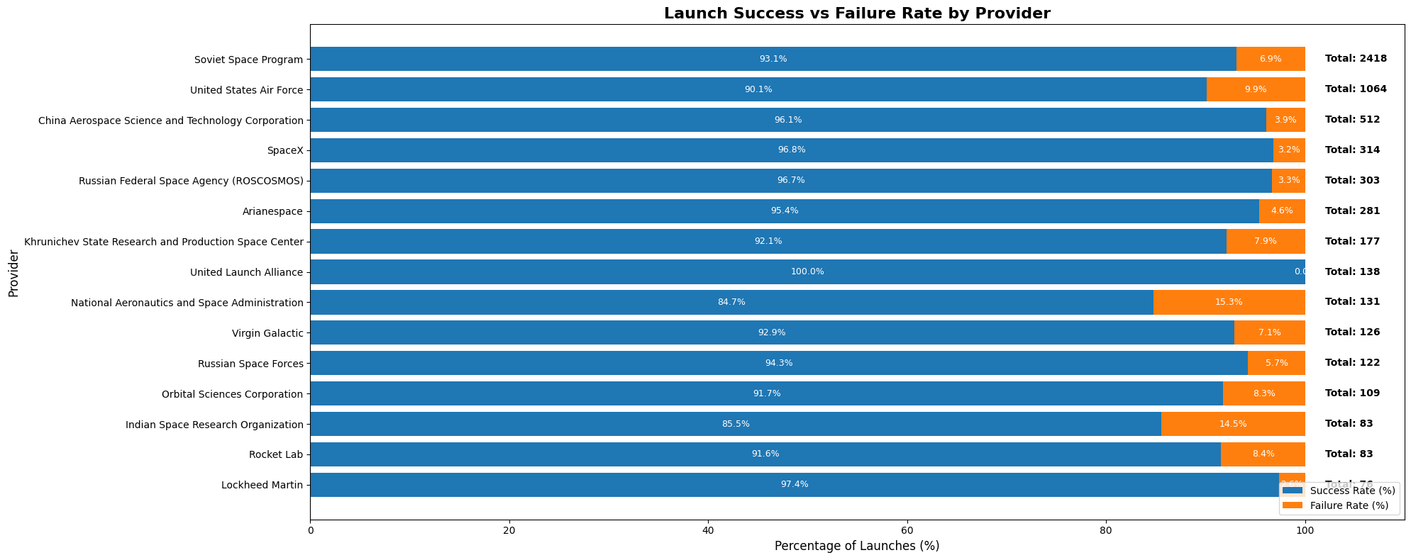
Figure 1.2
Interpretation: Providers such as SpaceX, Roscosmos and ULA show consistently strong success rates compared other companies.

Q3. Global Launch Reliability Over Time
This visualization shows how the overall global launch success rate has evolved over decades.
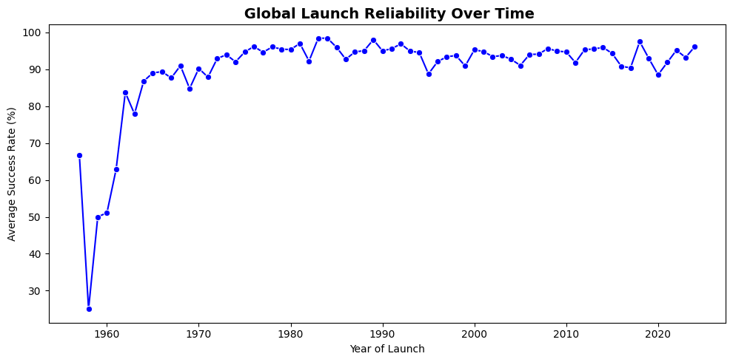
Figure 1.3
Q4. Number of Launches by Company Group
This analysis groups providers into categories Commercial, Military, and Scientific to identify trends across different mission types.
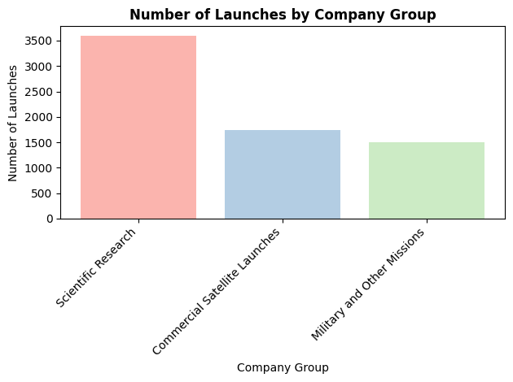
Figure 1.4
Interpretation: Scientific Research missions have shown the most rapid growth reflecting increased private investment and the commercialization of space access.

Q5. Company Type vs Average Launch Reliability
This visualization compares the average success rate percentage across different company mission types.
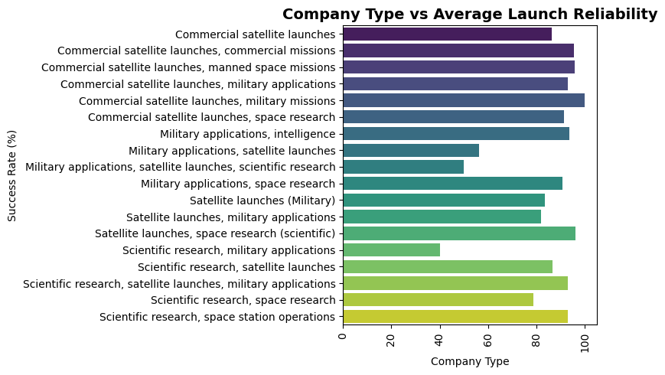
Figure 1.5
Interpretation: Scientific, Commercial companies demonstrate competitive success rate, indicating technological maturity and effective risk management.
From the above figures (Figure 1.2 and Figure 1.3), the success rates are calculated using
$Success Rate =\frac{ Number of Successful Launches​}{Total Number of Launches}*$100
(formula 1.1)

Measuring Company Reliability
- Importance of Success Rate
The success rate of the company directly indicates the operational reliability of that company. The study of reliability includes the analysing historical launch data and calculating the success ratio for each company. Formula 1.1 provides a statistical measure of the company’s operational consistency. These metrics also serve as input features for training machine learning models in the predictive analysis phase.
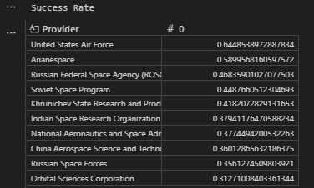
Figure 1.6

- Importance of Consistency (Stability Over Time)
Consistency is another crucial factor in determining reliability. A company with a high success rate must also maintain that performance steadily over time. Fluctuations in reliability may indicate issues in processes, technology, or quality control. Conversely, sustained consistency reflects organizational stability and technological maturity, making such companies more dependable for commercial and scientific satellite launches.
$$Consistency Measure=1- Standard Deviation of Annual Success Rates$$
Formula 1.2
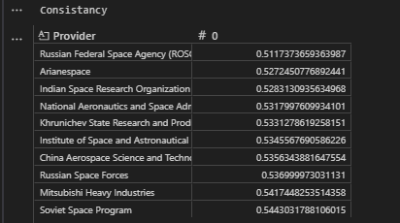
Figure 1.7
- Company Reliability Metrix (Combined Metrics)
Both success rate and consistency play a crucial role in determining the overall reliability of a space launch company. While success rate reflects the company’s ability to achieve successful missions, consistency measures the stability of this performance over time. Together, they provide a more comprehensive picture of a company’s operational dependability.
To create a single reliability indicator that investors and decision-makers can interpret easily, both metrics are combined into a weighted formula. Since the success rate is considered more influential in evaluating reliability, it is given 80% weight, while consistency contributes 20% to the overall metric.
$$Reliability=(0.8*successrate+0.2*consistancy)*100$$
Formula 1.3
This combined metric helps stakeholders identify which companies consistently deliver successful missions while maintaining operational stability. It serves as a practical decision-support measure for investors, commercial clients, and research institutions when choosing dependable partners for satellite launches.
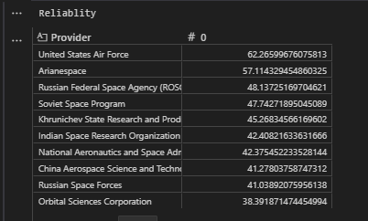
Figure 1.8
This table provides a clear comparison of how different companies perform in terms of both reliability and operational stability.
A higher reliability score indicates stronger performance and consistency, making the company a more dependable choice for satellite launch missions.
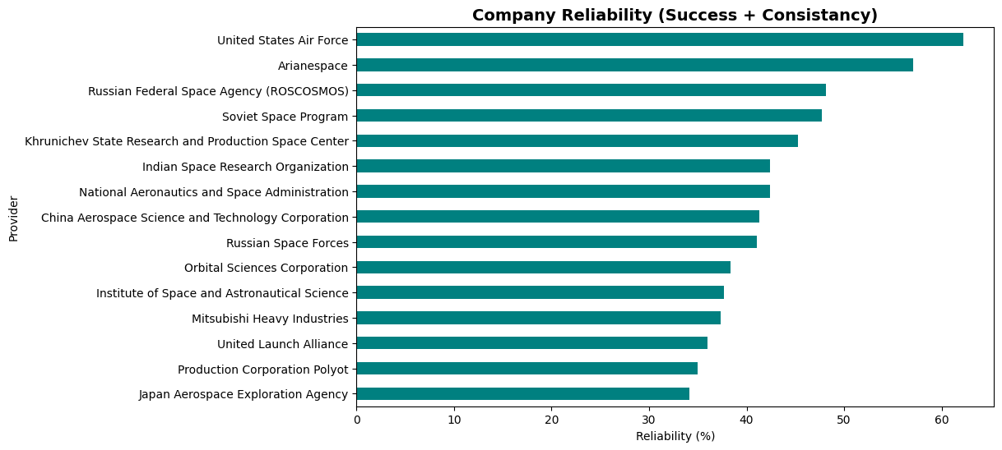
Figure 1.9
The above graph provides a visual interpretation of the reliability values listed in Figure 1.9. By plotting the computed reliability scores, allowing for a clearer comparison of company performance based on the combined success rate and consistency metrics.

Success Prediction Using Comparative Machine Learning Models
To forecast the likelihood of future launch outcomes, several machine learning models were developed and evaluated. Since the dataset is highly imbalanced (majority of missions are successful), To determine which algorithm best predicts success for our dataset, five different machine learning models were trained and evaluated. These are machine learning models used:
- Logistic Regression - a linear baseline classifier
- Random Forest Classifier - an ensemble decision-tree model
- Neural Network - a deep learning approach for nonlinear patterns
- Catboost Classifier– a gradient Boosting Model
- Support Vector Classifier - finds the optimal separating hyperplane
All models were trained using the same pre-processed dataset. Each model was tested under three sampling strategies Normal (original dataset), SMOTE oversampling, and Random Under sampling to understand how data balancing affects performance. Each model was trained using the same feature-engineered dataset and evaluated using Accuracy and ROC-AUC scores, as these metrics best capture performance on imbalanced data.

Sampling Techniques Used
To address the highly imbalanced nature of the launch-outcome dataset, three training approaches were used for every model:
- Normal Training (No Resampling)
The model was trained on the original imbalanced dataset to observe baseline performance.
- Oversampling (Minority Class Up-sampling)
To address the severe imbalance in the dataset, the minority class (failed launches) was increased so that its size matched the majority class. Oversampling was performed using SMOTETomek from the imblearn library, which combines:
- SMOTE – synthetically generates new minority samples based on nearest-neighbour interpolation. Tomek Links Removal – cleans overlapping samples to reduce noise and improve class separability.
- Under sampling (Majority Class Down-sampling)
Undersampling was performed by reducing the number of majority-class samples (successful launches) to equal the minority-class count. The RandomUnderSampler from imblearn was used to randomly select a balanced subset of the majority class.
This creates a balanced dataset and prevents the model from being biased toward success predictions.
Logistic Regression
A simple linear classifier that predicts the probability of launch success using a weighted combination of input features.
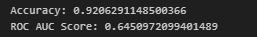
Logistic regression original dataset: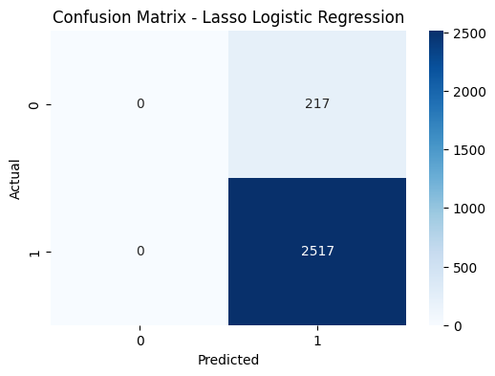
Logistic regression on oversampled dataset:
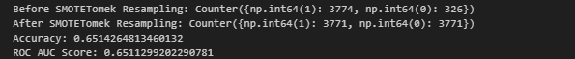
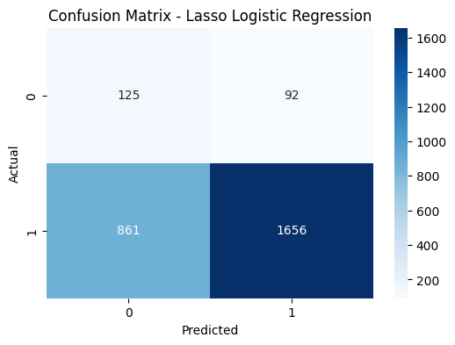
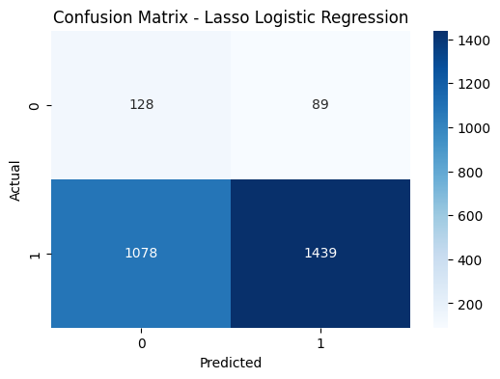
Logistic regression on undersampled dataset:
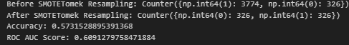

Random Forest:
An ensemble of multiple decision trees that captures nonlinear patterns in the launch data.
It improves prediction stability by averaging outcomes across many trees, reducing overfitting.
Random Forest Original Dataset:
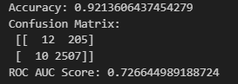
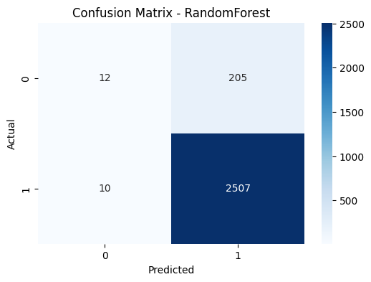

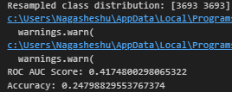
Random forest on oversampled dataset: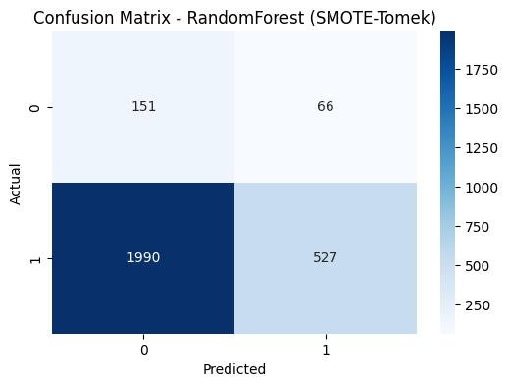
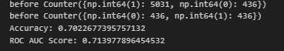
Random forest on undersampled dataset:
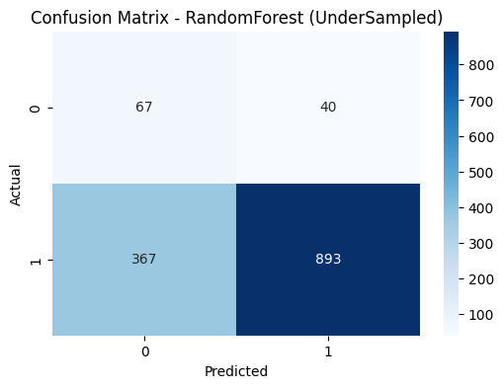
Neural Network
A multilayer feed-forward network capable of modeling complex and nonlinear relationships between features
Neural network original dataset:
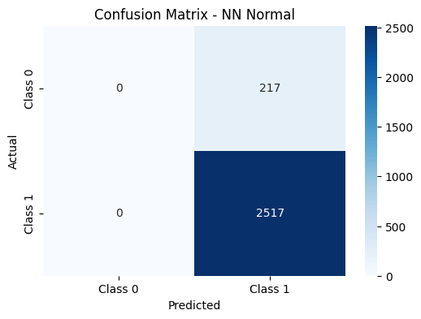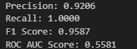
Neural network oversampled dataset:
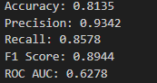
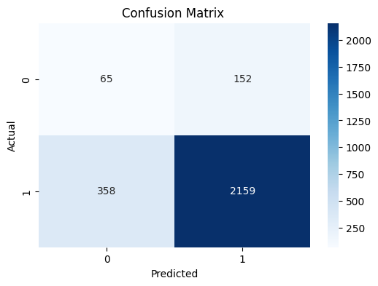
Neural network undersampled dataset:
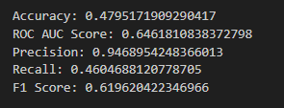
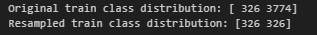
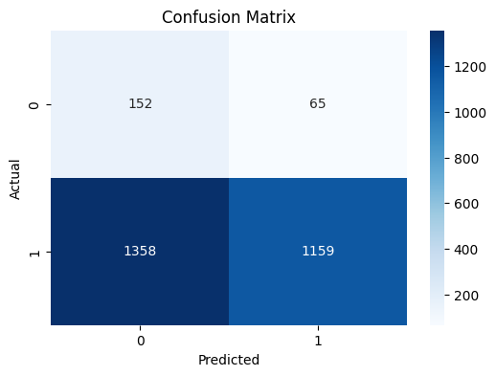

Catboost Classifier

A gradient-boosting algorithm designed to handle categorical features efficiently and reduce overfitting. It builds sequential decision trees and often delivers strong performance on structured tabular datasets.

Catboost Classifier on original dataset:

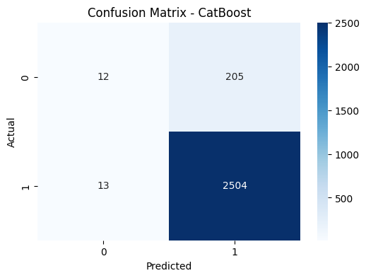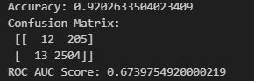

Catboost Classifier on oversampled dataset:

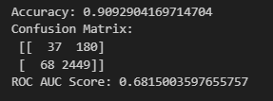
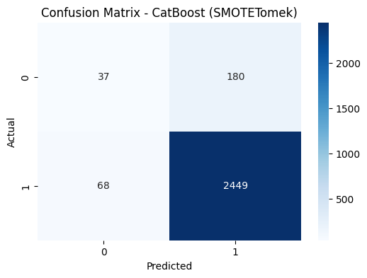

Catboost Classifier on undersampled dataset:

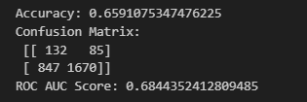
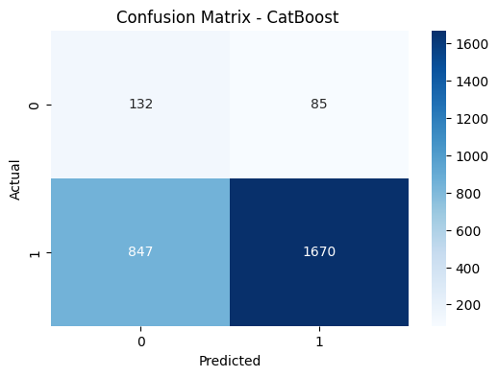

Support Vector Classifier

Support Vector Classifier is a margin-based classifier that finds the optimal decision boundary between success and failure classes

Support vector classifier on original dataset:

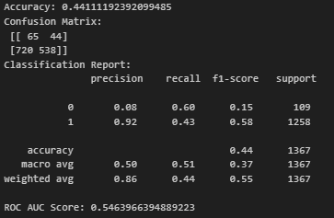
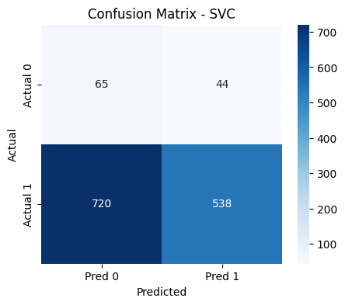

Support vector classifier on oversampled dataset:

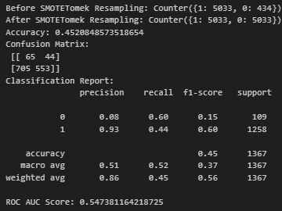
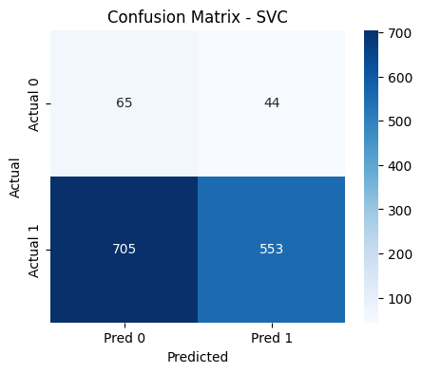

Support vector classifier on undersampled dataset:

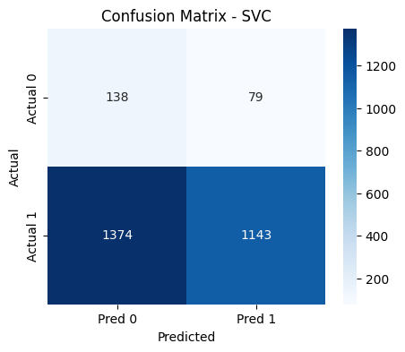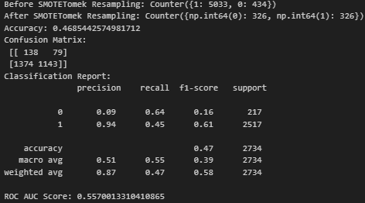

Ranking all model performances

To compare the effectiveness of all machine learning models, their evaluation metrics Accuracy, Precision, Recall, F1-Score, and ROC-AUC were compiled for each sampling method (Normal, Oversampling, and Undersampling). Each metric was given equal weight, and a combined performance score was computed to rank the models. The aggregated results are presented in the following summary table and performance comparison graph.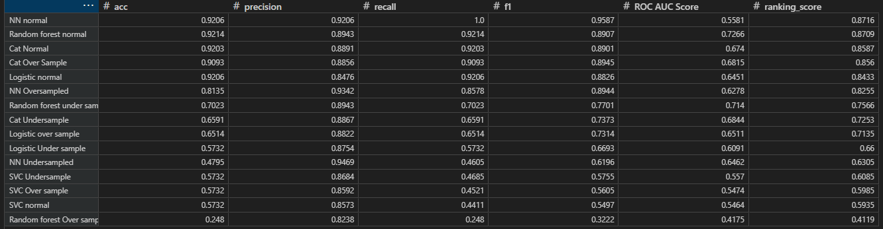

Figure 2.0
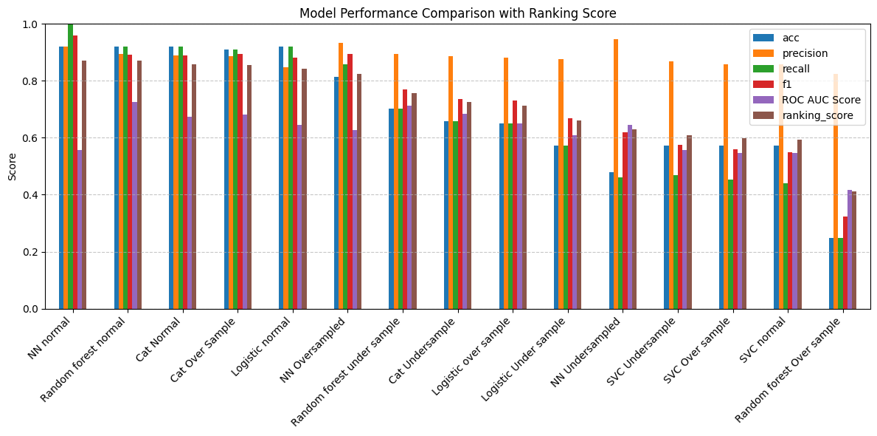
Figure 2.1

Based on the combined scoring:
- Neural Network achieved the highest performance in the normal (original) dataset.
- CatBoost Classifier performed best under Oversampling, effectively handling the enhanced minority class.
- Random Forest Classifier showed the strongest performance under Undersampling, demonstrating robustness even with reduced data.
These results highlight that no single model dominates across all sampling strategies, and performance varies depending on the class balance applied during training.
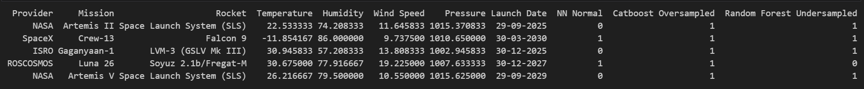
Figure 2.2
Table Figure 2.2 presents the predicted outcomes of five future space missions using three models Neural Network, CatBoost (oversampled), and Random Forest (undersampled). The Neural Network produced mixed results, CatBoost predicted all missions as successful, and Random Forest gave a balanced set of predictions. These outputs are purely model-generated and do not represent actual or official mission outcomes. The comparison demonstrates how different algorithms and sampling strategies influence future launch outcome forecasting.

Recommendations and Conclusions

Recommendations
Based on the findings, satellite operators and commercial clients are advised to select launch providers that demonstrate not only high success rates but also stable performance over long periods, as true reliability depends on consistency rather than isolated yearly results. Providers with fluctuating success trends should focus on improving process stability and analysing the causes of past failures. Future research can expand the analysis by including more technical launch parameters such as launch vehicle weight, number of stages, engine performance, booster reuse history, and anomaly records. Incorporating these features can help build more accurate and realistic prediction models for assessing mission success.

Conclusion
This study analysed more than sixty years of global launch data to evaluate the reliability of major space launch providers and to predict mission success using machine learning models. Reliability was assessed using success ratios, consistency trends across decades, and a combined weighted metric, highlighting that stable long-term performance is a key indicator of dependable launch operations. Five machine learning models Logistic Regression, Random Forest, Neural Network, SVC, and CatBoost were evaluated under normal, oversampled, and undersampled conditions. The results showed that Neural Networks performed best on the original dataset, CatBoost delivered the highest accuracy with oversampling, and Random Forest gave the best results with undersampling, demonstrating that model performance varies depending on class distribution.
Overall, this project offers a structured framework for identifying reliable launch providers and shows how machine learning can meaningfully enhance mission planning and decision-making in the space industry.
Bibliography & References:
- Fernández, L. A., Wiedemann, C., & Braun, V. (2022). Analysis of Space Launch Vehicle Failures and Post-Mission Disposal Statistics. Aerotecnica Missili & Spazio, 101, 243–256. https://doi.org/10.1007/s42496-022-00118-5
- Guarro, S. (2018). Launch Vehicle Reliability and Risk Metrics: Definition and Estimation in Relation to Requirements. Proceedings of the 14th International Conference on Probabilistic Safety Assessment and Management (PSAM 14). International Association for Probabilistic Safety Assessment and Management. https://iapsam.org/psam14/proceedings/paper/paper_411_1.pdf
- Koelle, D. E. (2003). Handbook of Cost Engineering for Space Transportation Systems.
- NASA Launch Services Program. (2023). Launch Vehicle Performance Data. NASA Technical Report.
- Breiman, L. (2001). Random Forests. Machine Learning, 45(1), 5–32.
- Chen, T., & Guestrin, C. (2016). XGBoost: A Scalable Tree Boosting System. In Proceedings of the 22nd ACM SIGKDD International Conference on Knowledge Discovery and Data Mining (pp. 785–794).
- Rumelhart, D. E., Hinton, G. E., & Williams, R. J. (1986).
Learning representations by back-propagating errors. Nature, 323(6088), 533–536.
- Goodfellow, I., Bengio, Y., & Courville, A. (2016). Deep learning. MIT Press.
Appendix
A1. Feature Engineering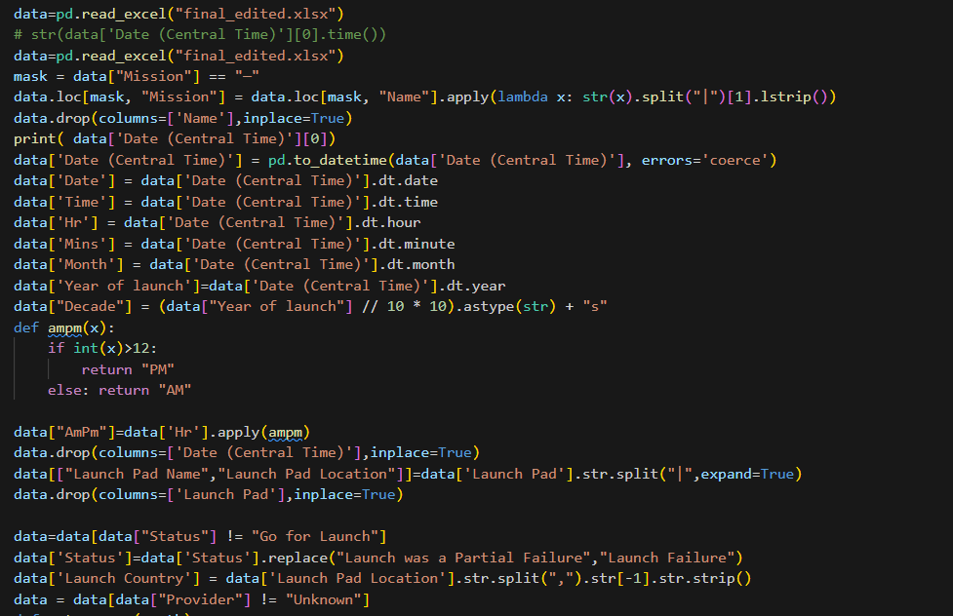

A2. Reliability Calculation Method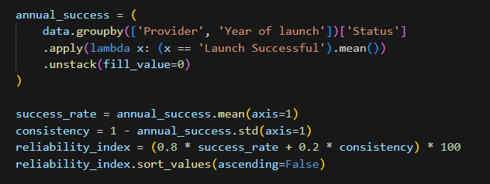
A3. CatBoost Model Implementation Parameters 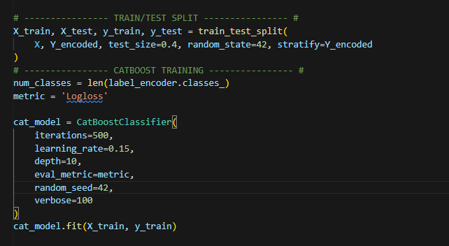

A4. Neural Network Model Parameters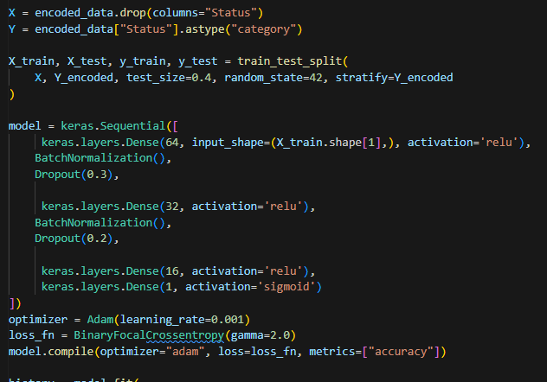
A5. Random Forest Classifier Parameters
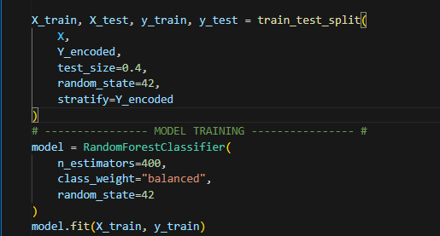
A6. Logistic Regression Model Parameters
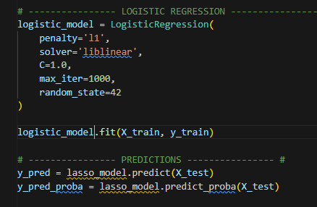
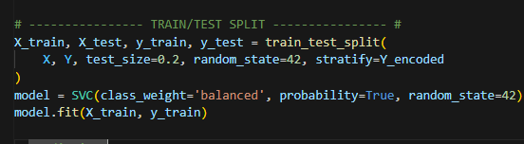
A7. Support Vector Classifier (SVC)

A8. Random Undersampling Technique
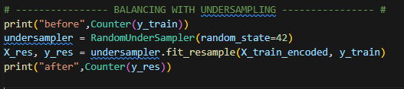
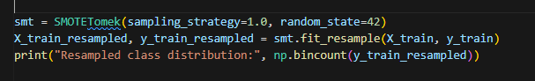
A9. Oversampling / Resampling Method
A10. Source Code: The complete source code used for this analysis is available at the following link: https://github.com/NAGSnag/Space-Industry-Reliability-Study-and-Success-Prediction-using-Comparative-ML-Models.git

